Single Page Application
Introducing React
Version 1.0


Amendment Record Sheet

Version No. | Date | Amendment Description | Amended By | Approved By
1.0 | 12 October 2016 | Approved document | Gerry Byrne | David Wilson

Topic Overview

This topic will introduce the use of the React JavaScript framework to help in providing an MVC solution. We will use the routing facility with React.

Topic Objectives

At the end of this topic you will be able to:

- Reference a CDN to access React and ReactDOM
- Reference a CDN to access React routing
- Reference a CDN to access Babel

Contents

Exercise One – Creating an interactive course list 5
Exercise Two – Adding new courses 8
Exercise Three – Removing courses 11
Exercise Four – Error handling 14

Exercise One – Creating an interactive course list

Displaying the Initial Frame
When we build a single-page app we will always have a section of our page that will remain static. This static part, is often referred to as an app frame. It can be something as simple as one invisible HTML element that acts as the container for all of our content, or it could include some additional visual things like a header, footer, navigation, etc. In our example we will create the app frame to hold our navigation header and an empty area for content to be loaded into. To display the content we will create a component that is going to be responsible for this.

This basic HTML5 code will introduce you to the requirements for a web page in HTML5 which includes a basic React section. The application will create a render that will display a simple list

- Open you text editor.
- Click on the File menu.
- Choose New.
- Click on the File menu.
- Choose Save As.
- Choose the location where you wish to save the file.
- In the text box to the right of the File name label enter the name of the HTML file you wish to create – ReactJSRouterV1.html.
- Choose Hyper Text Markup Language file from the drop down list to the right of the Save as type label.
- Click the Save button.
- Make sure the ReactJSRouterV1.html file is open in the text editor.
- Amend the code as shown below:

<!DOCTYPE html>
<html>
<head>
<meta charset="UTF-8" />
<title>Gerry Byrne - ReactJS Tutorials</title>
<script src="https://cdnjs.cloudflare.com/ajax/libs/react/0.14.0/react.js"></script>
<script src="https://cdnjs.cloudflare.com/ajax/libs/react/0.14.0/react-dom.js"></script>
<script src="https://cdnjs.cloudflare.com/ajax/libs/react/0.13.3/JSXTransformer.js"></script>
<script src="https://cdnjs.cloudflare.com/ajax/libs/babel-core/5.8.24/browser.min.js"></script>
<script src="https://cdnjs.cloudflare.com/ajax/libs/react-router/2.4.0/ReactRouter.min.js"></script>
</head>
<body>
<div id="contentgoeshere"></div>
<script type="text/babel">
var App = React.createClass({
render: function() {
return (
<div>
<h1>React Single Page Application</h1>
<ul className="header">
HTML List
<li>React</li>
<li>Angular</li>
<li>Ember</li>
<li>Meteor</li>
</ul>
<div className="content">
The list above is a HTML list based on hard coded values
</div>
</div>
)
}
});

ReactDOM.render(
Render list to contentgoeshere
<div>
<App/>
</div>,
contentgoeshere
);
</script>
</body>
</html>

- Click on the Run menu.
- Choose Launch in Chrome.

The browser window will appear with the following web page displaying the course list:

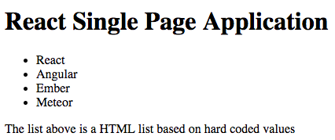
List

Code Analysis

- We have a component called App that returns some HTML.
- The ReactDOM.render call references this App component and displays it at the section called contentgoeshere.
- We have not used React Router at all, yet.

Exercise Two – Using React Router
We will amend the code from the previous example to use the React Router.

- Open you text editor.
- Click on the File menu.
- Choose New.
- Click on the File menu.
- Choose Save As.
- Choose the location where you wish to save the file.
- In the text box to the right of the File name label enter the name of the HTML file you wish to create – ReactJSRouterV2.html.
- Choose Hyper Text Markup Language file from the drop down list to the right of the Save as type label.
- Click the Save button.
- Make sure the ReactJSRouterV2.html file is open in the text editor.
- Amend the code as shown below to change the ReactDom.render section to use routing:

<!DOCTYPE html>
<html>
<head>
<meta charset="UTF-8" />
<title>Gerry Byrne - ReactJS Tutorials</title>
<script src="https://cdnjs.cloudflare.com/ajax/libs/react/0.14.0/react.js"></script>
<script src="https://cdnjs.cloudflare.com/ajax/libs/react/0.14.0/react-dom.js"></script>
<script src="https://cdnjs.cloudflare.com/ajax/libs/react/0.13.3/JSXTransformer.js"></script>
<script src="https://cdnjs.cloudflare.com/ajax/libs/babel-core/5.8.24/browser.min.js"></script>
<script src="https://cdnjs.cloudflare.com/ajax/libs/react-router/2.4.0/ReactRouter.min.js"></script>

</head>
<body>
<div id="contentgoeshere"></div>
<script type="text/babel">
var App = React.createClass({
render: function() {
return (
<div>
<h1>React Single Page Application</h1>
<ul className="header">
<li>React</li>
<li>Angular</li>
<li>Ember</li>
<li>Meteor</li>
</ul>

<div className="content">
The list above is a HTML list based on hard coded values

</div>
</div>
)
}
});

ReactDOM.render(
<ReactRouter.Router>
<ReactRouter.Route path="/" component={App}>
</ReactRouter.Route>
</ReactRouter.Router>,
contentgoeshere
);

</script>
</body>
</html>

- Click on the Run menu.
- Choose Launch in Chrome.

The browser window will appear with the following web page displaying the course list:

Same list

We see our App component displayed just like the previous version.
So why that is the case – we will move from the core React concepts and look at React Router itself.

In our new code we specified a Router component:
ReactDOM.render(
<ReactRouter.Router>
<ReactRouter.Route path="/" component={App}>

</ReactRouter.Route>
</ReactRouter.Router>,
contentgoeshere
);
The Router component is part of the React Router API and its job is to deal with all of the routing-related logic our app will need. Inside this component, we specified what is known as the routing configuration. Sounds very complicated but in reality it is simply a term used to describe the mapping between URLs and the views. The specifics of all this are handled by another component called Route:

The Route component takes several props that help define what to display at what URL:
- The path prop specifies the URL we are interested in matching. In our example it is the root /.
- The component prop allows us to specify the name of the component we wish to display. In our case it is our App component.

If we therefore look at what we have said it is:
If the URL you are on contains the root, go ahead and display the App component. Because this condition is true when we preview our app we see the result of what happens when our App component renders.

Exercise Three – Displaying the home page
As you can see React Router provides us with all of this routing functionality by mimicking concepts in React that we have already used i.e. components, props, and JSX. In our example we have displayed the apps frame using this principle. Now we want to extend this and define the content that we will display as part of our home view.

So we will create a component called Home that will contain the markup we want to display. We will amend the code from the previous example.

- Open you text editor.
- Click on the File menu.
- Choose New.
- Click on the File menu.
- Choose Save As.
- Choose the location where you wish to save the file.
- In the text box to the right of the File name label enter the name of the HTML file you wish to create – ReactJSRouterV3.html.
- Choose Hyper Text Markup Language file from the drop down list to the right of the Save as type label.
- Click the Save button.
- Make sure the ReactJSRouterV3.html file is open in the text editor.
- Amend the code as shown below to add a Home component, just above where we have our App component defined:

<!DOCTYPE html>
<html>
<head>
<meta charset="UTF-8" />
<title>Gerry Byrne - ReactJS Tutorials</title>
<script src="https://cdnjs.cloudflare.com/ajax/libs/react/0.14.0/react.js"></script>
<script src="https://cdnjs.cloudflare.com/ajax/libs/react/0.14.0/react-dom.js"></script>
<script src="https://cdnjs.cloudflare.com/ajax/libs/react/0.13.3/JSXTransformer.js"></script>
<script src="https://cdnjs.cloudflare.com/ajax/libs/babel-core/5.8.24/browser.min.js"></script>
<script src="https://cdnjs.cloudflare.com/ajax/libs/react-router/2.4.0/ReactRouter.min.js"></script>
</head>
<body>
<div id="contentgoeshere"></div>
<script type="text/babel">

var Home = React.createClass({
render: function() {
return (
<div>
<h2>Allstate NI Graduate Application</h2>
<p>Allstate Northern Ireland, was established in Belfast in 1999
to provide high quality software development services and business
solutions in support of our U.S. parent's global operations.
The Allstate Corporation is the largest publically held personal
lines property and casualty insurer in America.</p>

<p>Allstate Northern Ireland is committed to helping promote IT within
the province with alliances with a number of organisations such as
Invest Northern Ireland, The Department of Employment and Learning,
Sync NI, Catalyst Inc, Letterkenny IT, CSIT and both of the universities
in Northern Ireland, Queen's University Belfast and the University of Ulster.</p>
</div>
);
}
});

var App = React.createClass({
render: function() {
return (

- Amend the code as shown below to add the Home component to the location on the HTML page where we want it displayed. In our case replace the existing content in the div within the App:

Sync NI, Catalyst Inc, Letterkenny IT, CSIT and both of the universities
in Northern Ireland, Queen's University Belfast and the University of Ulster.</p>
</div>
);
}
});
var App = React.createClass({
render: function() {
return (
<div>
<h1>React Single Page Application</h1>
<ul className="header">
<li>React</li>
<li>Angular</li>
<li>Ember</li>
<li>Meteor</li>
</ul>
<div className="content">
<Home/>
</div>
</div>
)
}
});

- Click on the Run menu.
- Choose Launch in Chrome.

The browser window will appear with the following web page displaying the course list:

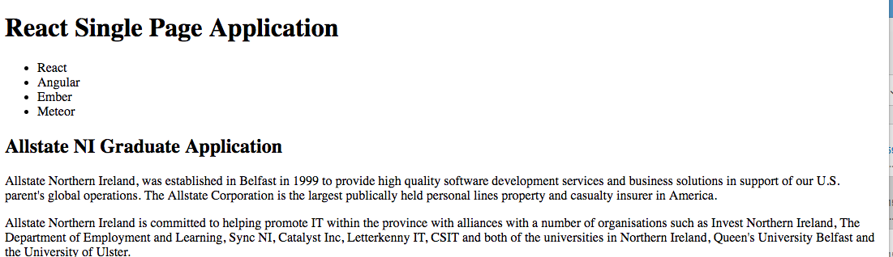
Home component displayed

We can see our navigation header and this is followed by the contents of our Home component.

While this approach works, it is the wrong thing to do. It is wrong because it complicates our desire to load other pieces of content as the user is navigating around our app. We have essentially hard-coded our app to only display the Home component. This is an issue but we will return to this later.

Exercise Four – ‘Prettying’ the display with some CSS
We will now take the opportunity to style the app with some CSS. We will create a style tag in the head tag of the code and we will add our CSS within it.

- Open you text editor.
- Click on the File menu.
- Choose New.
- Click on the File menu.
- Choose Save As.
- Choose the location where you wish to save the file.
- In the text box to the right of the File name label enter the name of the HTML file you wish to create – ReactJSRouterV4.html.
- Choose Hyper Text Markup Language file from the drop down list to the right of the Save as type label.
- Click the Save button.
- Make sure the ReactJSRouterV4.html file is open in the text editor.
- Amend the code as shown below to add the CSS styling we require:

<!DOCTYPE html>
<html>
<head>
<meta charset="UTF-8" />
<title>Gerry Byrne - ReactJS Tutorials</title>
<script src="https://cdnjs.cloudflare.com/ajax/libs/react/0.14.0/react.js"></script>
<script src="https://cdnjs.cloudflare.com/ajax/libs/react/0.14.0/react-dom.js"></script>
<script src="https://cdnjs.cloudflare.com/ajax/libs/react/0.13.3/JSXTransformer.js"></script>
<script src="https://cdnjs.cloudflare.com/ajax/libs/babel-core/5.8.24/browser.min.js"></script>
<script src="https://cdnjs.cloudflare.com/ajax/libs/react-router/2.4.0/ReactRouter.min.js"></script>

<style>
body {
background-color: #33BDFF;
padding: 20px;
margin: 0;
}
h1, h2, p, ul, li {
font-family: Helvetica, Arial, sans-serif;
}
ul.header li {
display: inline;
list-style-type: none;
margin: 0;
}
ul.header {
background-color: #111;
padding: 0;
}
ul.header li a {
color: #FFF;
font-weight: bold;
text-decoration: none;
padding: 20px;
display: inline-block;
}
.content {
background-color: #FFFFFF;
padding: 20px;
}
.content h2 {
padding: 0;
margin: 0;
}
.content li {
margin-bottom: 10px;
}
</style>

</head>
<body>
<div id="contentgoeshere"></div>
<script type="text/babel">

We are simply taking a short cut and using CSS in its markup form, we are not using the inline style object approach. Once you have added this CSS our app will start to look more stylish.

- Click on the Run menu.
- Choose Launch in Chrome.

The browser window will appear with the following web page displaying the course list:

Body background colour is #33BDFF

We can see our navigation header has disappeared, we will fix this shortly. The elements aren't visible because they blended in with the black background once we added the CSS in.

Exercise Five – ES6 Trick to handle prefixes
As you can see from the code every time we call something defined by the React Router API, we prefix it with the word ReactRouter.

<ReactRouter.Router>
<ReactRouter.Route path="/" component={App}>

</ReactRouter.Route>
</ReactRouter.Router>

Now from our coding experience we should be thinking that this is a rather cumbersome coding style that is giving us extra work. There is of course a solution and ES6 allows us to manually specify which values will automatically get prefixed. We can therefore amend to add the following:

var { Router,
Route,
IndexRoute,
IndexLink,
Link } = ReactRouter;

If we have this code then every time we use one of the values defined inside the brackets the prefix ReactRouter will automatically be added for us when our app runs.

This will now allow us to remove the ReactRouter prefix from our Router and Routecomponent instances in our ReactDOM.render method.

- Open you text editor.
- Click on the File menu.
- Choose New.
- Click on the File menu.
- Choose Save As.
- Choose the location where you wish to save the file.
- In the text box to the right of the File name label enter the name of the HTML file you wish to create – ReactJSRouterV5.html.
- Choose Hyper Text Markup Language file from the drop down list to the right of the Save as type label.
- Click the Save button.
- Make sure the ReactJSRouterV5.html file is open in the text editor.
- Amend the code as shown below to add the code required for the automatic allocation of the ReactRouter prefix:

</head>
<body>
<div id="contentgoeshere"></div>
<script type="text/babel">

var { Router,
Route,
IndexRoute,
IndexLink,
Link } = ReactRouter;

var Home = React.createClass({
render: function() {
return (

We are simply taking a short cut and using CSS in its markup form, we are not using the inline style object approach. Once you have added this CSS our app will start to look more stylish.

- Amend the code as shown below to remove the ReactRouter prefix from our Route and Router component instance:

ReactDOM.render(
<Router>
<Route path="/" component={App}>
</Route>
</Router>,
contentgoeshere
);

</script>
</body>
</html>

- Click on the Run menu.
- Choose Launch in Chrome.

The browser window will appear with the same web page as before, nothing has really changed, except our code is more maintainable.
Body background colour is #33BDFF

Exercise Six – Displaying the home page correctly
Earlier we said we had our home page displaying in an incorrect manner. The page does display but the approach does not make it easy for us to load anything other than the home page when users navigate around. As we said the call to our Home component is hard coded inside App.

The correct solution involves letting React Router handle which component to call depending on what your current URL structure is. This involves nesting Route components inside Route components to better define the URL-to-view mapping further.

So let us go back to our ReactDOM.render method and make some changes.

- Open you text editor.
- Click on the File menu.
- Choose New.
- Click on the File menu.
- Choose Save As.
- Choose the location where you wish to save the file.
- In the text box to the right of the File name label enter the name of the HTML file you wish to create – ReactJSRouterV6.html.
- Choose Hyper Text Markup Language file from the drop down list to the right of the Save as type label.
- Click the Save button.
- Make sure the ReactJSRouterV6.html file is open in the text editor.
- Amend the code as shown below to add the Home component using the IndexRoute method:

ReactDOM.render(
<Router>
<Route path="/" component={App}>
<IndexRoute component={Home}/>
</Route>
</Router>,
contentgoeshere
);

</script>
</body>
</html>

Inside our root Route element we are defining another route element of type IndexRoute and setting its view to be our Home component.

There is one more change we need to make inside our App component. We need to remove the call to the Home component and replace it with the following highlighted line:

- Amend the code as shown below:

var App = React.createClass({
render: function() {
return (
<div>
<h1>React Single Page Application</h1>
<ul className="header">
<li>React</li>
<li>Angular</li>
<li>Ember</li>
<li>Meteor</li>
</ul>
<div className="content">
{this.props.children}

</div>
</div>
)
}
});

- Click on the Run menu.
- Choose Launch in Chrome.

The browser window will appear with the our home content displayed. The difference this time is that we are displaying the home content properly in a way that does not prevent other content from being displayed instead. This is because of two things:
- What gets displayed inside App is controlled by the result of this.props.children instead of a hard-coded component.
- Our Route element inside ReactDOM.render contains an IndexRouteelement whose sole purpose for existing is to declare which component will be displayed when your app initially loads.
Body background colour is #33BDFF

Exercise Seven – Creating the navigation links (routes)
The way we specify navigation links in React Router is not by directly using the tried and tested a tag and throwing in a path through the href attribute. Instead, we specify our navigation link using React Router's Link components that are similar to a tags but offer a lot more functionality. To see the Link component in action we will modify our existing navigation elements to look like the following highlighted lines:

- Open you text editor.
- Click on the File menu.
- Choose New.
- Click on the File menu.
- Choose Save As.
- Choose the location where you wish to save the file.
- In the text box to the right of the File name label enter the name of the HTML file you wish to create – ReactJSRouterV7.html.
- Choose Hyper Text Markup Language file from the drop down list to the right of the Save as type label.
- Click the Save button.
- Make sure the ReactJSRouterV7.html file is open in the text editor.
- Amend the code as shown below to add the link to the list items:

var App = React.createClass({
render: function() {
return (
<div>
<h1>React Single Page Application</h1>
<ul className="header">
<li><Link to="/">React</Link></li>
<li><Link to="/angular">Angular</Link></li>
<li><Link to="/ember">Ember</Link></li>
<li><Link to="/meteor">Meteor</Link></li>
</ul>
<div className="content">
{this.props.children}
</div>
</div>
)
}
});

Looking at this code we have added our Link components and they specify a prop to be called. This prop specifies the value of the URL we will display in the address bar. Indirectly, it also specifies the location we will be telling React Router we are virtually navigating to. Our Home link takes users to the root ( / ), the Angular link takes users to a location called angular, the Ember link takes users to a location called ember, and the Meteor link takes users to a location called meteor.

- Click on the Run menu.
- Choose Launch in Chrome.

We can see the amended page. If we click on the links we will not see any difference, the display will stay the same. We simply continue to see your Home content because that is all that we had specified earlier. On the other hand we can see the URLs updating in the address bar when we click on a link.
Body background colour is #33BDFF

Exercise Eight – Adding the additional views for the routes
Now we will define the components for our Angular, Ember and Meteor views that we linked to earlier. In your code just below where you have your Home component, go ahead and add in the following:

- Open you text editor.
- Click on the File menu.
- Choose New.
- Click on the File menu.
- Choose Save As.
- Choose the location where you wish to save the file.
- In the text box to the right of the File name label enter the name of the HTML file you wish to create – ReactJSRouterV8.html.
- Choose Hyper Text Markup Language file from the drop down list to the right of the Save as type label.
- Click the Save button.
- Make sure the ReactJSRouterV8.html file is open in the text editor.
- Amend the code as shown below to add the required Angular component, it will be added below the Home component:

var Home = React.createClass({
render: function() {
return (
<div>
<h2>Allstate NI Graduate Application</h2>
<p>Allstate Northern Ireland, was established in Belfast in 1999
to provide high quality software development services and business
solutions in support of our U.S. parent's global operations.
The Allstate Corporation is the largest publically held personal
lines property and casualty insurer in America.</p>

<p>Allstate Northern Ireland is committed to helping promote IT within
the province with alliances with a number of organisations such as
Invest Northern Ireland, The Department of Employment and Learning,
Sync NI, Catalyst Inc, Letterkenny IT, CSIT and both of the universities
in Northern Ireland, Queen's University Belfast and the University of Ulster.</p>
</div>
);
}
});

var Angular = React.createClass({
render: function() {
return (
<div>
<h2>Allstate NI Graduate Application</h2>
<p><h2>Declarative</h2>
React makes it painless to create interactive UIs.
Design simple views for each state in your application,
and React will efficiently update and render just the
right components when your data changes.

Declarative views make your code more predictable and easier to debug.</p>

<p>
<h2>Component-Based</h2>
Build encapsulated components that manage their own state, then compose
them to make complex UIs. Since component logic is written in JavaScript
instead of templates, you can easily pass rich data through your app
and keep state out of the DOM.</p>
</div>
);
}
});

- Amend the code as shown below to add the required Ember component, it will be added below the Angular component:

var Angular = React.createClass({
render: function() {
return (
<div>
<h2>Allstate NI Graduate Application</h2>
<p><h2>Declarative</h2>
React makes it painless to create interactive UIs.
Design simple views for each state in your application,
and React will efficiently update and render just the
right components when your data changes.

Declarative views make your code more predictable and easier to debug.</p>

<p>
<h2>Component-Based</h2>
Build encapsulated components that manage their own state, then compose
them to make complex UIs. Since component logic is written in JavaScript
instead of templates, you can easily pass rich data through your app
and keep state out of the DOM.</p>
</div>
);
}
});

var Ember = React.createClass({
render: function() {
return (
<div>
<h2>Allstate NI Graduate Application</h2>
<p><h2>Ember</h2>
Ember.js is an open source JavaScript client-side framework for developing
the web applications and uses the MVC(Model-View-Controller) architecture
pattern. In Ember.js, route is used as model, handlebar template as view
and controller manipulates the data in the model.</p>

<p>
<h2>Features</h2>
<ul>
<li>Ember.js is used for to creating reusable and maintainable JavaScript web applications.</li>

<li>Ember.js views are created by using Handlebars templates and are simple to develop the front-end design.</li>

<li>It automatically determines the route and controller during declaration of the route resources.</li>

<li>Ember.js eliminates the boilerplate(the section of code that has to be included in various places without any alteration) and provides standard application architecture.</li>

<li>Ember.js has HTML and CSS at the core of the development model.</li>

<li>The routes are core features of the Ember.js which are used for to manage an URL's.</li>

<li>It has extensive view type support.</li>

<li>Ember.js uses templates that helps to automatically update the model, if contents of an applications gets change.</li>
</ul>
</p>
</div>
);
}
});

- Amend the code as shown below to add the required Meteor component, it will be added below the Ember component:

var Ember = React.createClass({
render: function() {
return (
<div>
<h2>Allstate NI Graduate Application</h2>
<p><h2>Ember</h2>
Ember.js is an open source JavaScript client-side framework for developing
the web applications and uses the MVC(Model-View-Controller) architecture
pattern. In Ember.js, route is used as model, handlebar template as view
and controller manipulates the data in the model.</p>

<p>
<h2>Features</h2>
<ul>
<li>Ember.js is used for to creating reusable and maintainable JavaScript web applications.</li>

<li>Ember.js views are created by using Handlebars templates and are simple to develop the front-end design.</li>

<li>It automatically determines the route and controller during declaration of the route resources.</li>

<li>Ember.js eliminates the boilerplate(the section of code that has to be included in various places without any alteration) and provides standard application architecture.</li>

<li>Ember.js has HTML and CSS at the core of the development model.</li>

<li>The routes are core features of the Ember.js which are used for to manage an URL's.</li>

<li>It has extensive view type support.</li>

<li>Ember.js uses templates that helps to automatically update the model, if contents of an applications gets change.</li>
</ul>
</p>
</div>
);
}
});

var Meteor = React.createClass({
render: function() {
return (
<div>
<h2>Allstate NI Graduate Application</h2>
<p><h2>Meteor</h2>
Meteor.js is a cohesive development platform, a collection of libraries
and packages that are bound together in a tidy way to make web development easier.
It builds on ideas from previous frameworks and libraries to offer an easy way
to start a prototype app, but it gives you the tools and flexibility to build a
full fledged production app. There are libraries like Tracker and Blaze that the
Meteor Development Group has built specifically for a reactive front-end experience.</p>

<p>
<h2>Why is Meteor good?</h2>
Meteor is a reactive, full stack JavaScript framework that allows developers to write single
page apps for desktop and mobile. Simply put, Meteor is a collection of tools that developers
use to write web apps that are fast and secure.

The core concept of Meteor is reactivity. Real time syncing of data is built into Meteor at
the core, but it does it in a different way. Instead of polling the server for updates every
few seconds, a Meteor app maintains a low-data connection to a server using a protocol called DDP.
DDP allows the server to send data to the client the instant it changes, since it had a continuous
connection with it. Reactivity encompasses more than this, though. When a client changes a piece
of data, Meteor renders the required UI change before the data gets sent to the server. This means
that changes seem to happen instantly, as the app doesn't have to wait for a round trip to the
server to complete.

Meteor has a ton of other cool things, like a templating system called Blaze, a database on the
client called Minimongo, and more. If you really are interested in learning Meteor, a book called
Disover Meteor, at discovermeteor.com, is definitely the way to go. It teaches everything you
need to know about Meteor, like routing, templating, subscriptions, publishing, and more, using
a real app that you build as the book progresses. It's a really, really good book and will help
you grasp the concepts of Meteor in only a few hours.
</p>
</div>
);
}
});

- Amend the code as shown below to add the Route paths for each component in the render function:

ReactDOM.render(
<Router>
<Route path="/" component={App}>
<IndexRoute component={Home}/>
<Route path="angular" component={Angular} />
<Route path="ember" component={Ember} />
<Route path="meteor" component={Meteor} />
</Route>
</Router>,
contentgoeshere
);

</script>
</body>
</html>

- Click on the Run menu.
- Choose Launch in Chrome.

What we have done is update the routing logic to display the Angular component if the URL contains the word angular, to display the Ember component if the URL contains the word ember and to display the Meteor component if the URL contains the word meteor.


Navagation bar

- Click on the Angular link in the navigation bar.

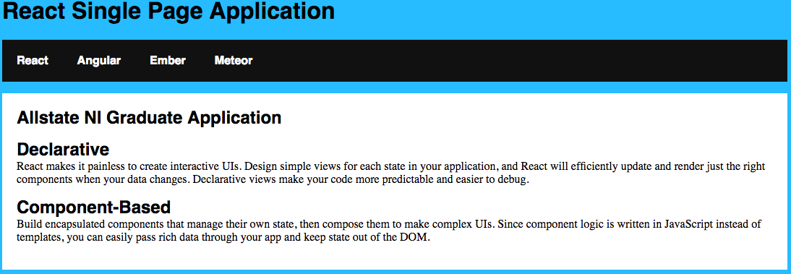
Angular component

- Click on the Ember link in the navigation bar.

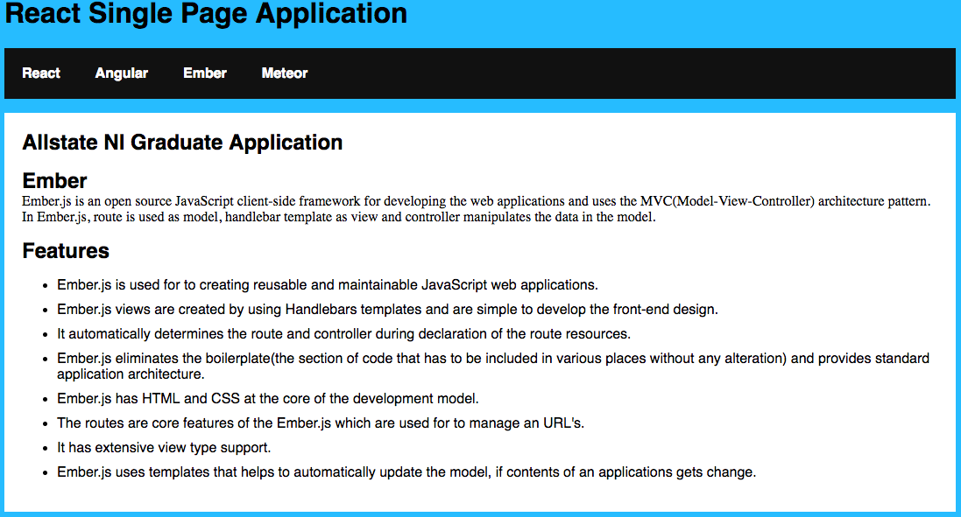
Ember component

- Click on the Meteor link in the navigation bar.

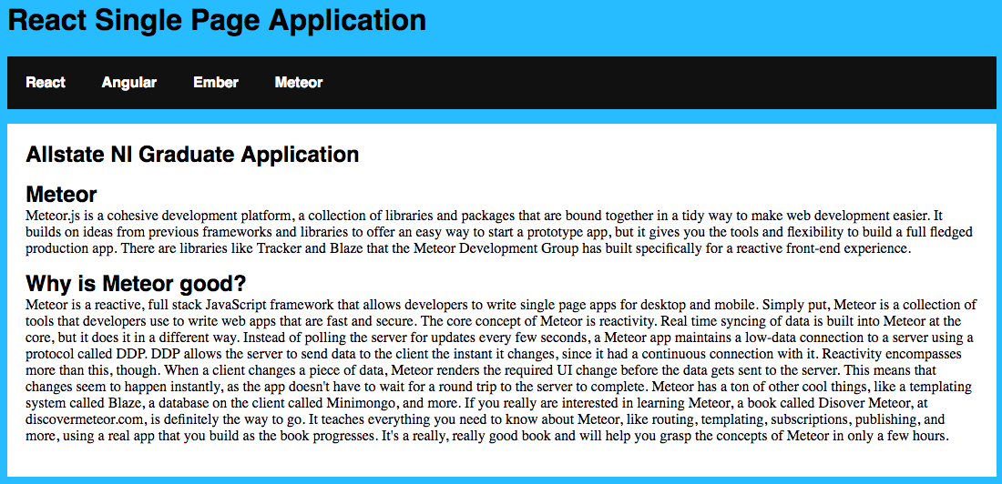
Meteor component

